**Intelligent Surveillance for Enhanced Road Safety Using Deep Learning Methodology and Real-Time Reporting**

Jyoti Kukade1, Keshav Soni2, Vidhya Samad Barpha4, Prashant Panse3

[jyotikukade21@gmail.com](mailto:jyotikukade21@gmail.com), [keshavsoni1622@gmail.com](mailto:keshavsoni1622@gmail.com) , vidhyasamad.barpha@medicaps.ac.in [prashantpanse@medicaps.ac.in](mailto:prashantpanse@medicaps.ac.in)

**Medi-Caps University, Indore**

**Abstract:**

Accidents are the main cause of mortality in India, where there are more than 13 lakh accidents annually and they are becoming worse every day. The inability to provide accident victims with prompt help accounts for more than 70% of accident-related deaths. An accident victim may go untreated for a very long period on roads with little to no traffic or traffic moving quickly. The goal is to develop a system that can locate an accident using a live video feed from a CCTV camera that has been mounted on a roadway and send sms alert with cctv location on emergency services. A deep learning convolution neural network model that has been trained to differentiate between accident- and non-accident-related video frames should be applied to each frame of a video. Convolutional neural networks have been shown to offer a quick and accurate way of identifying pictures. Proposed CNN-based image classifiers have shown accuracy values of over 83% for comparably smaller datasets and need less preprocessing than previous image classifying techniques.

**Keywords:**

Convolutional Neural Network, Accident Detection, Deep Learning, Video Classification

1. **Introduction :**

Road traffic accidents rank among the world's top causes of death and injury, with significant economic and social costs. Traditional methods of accident detection, such as visual inspection or manual monitoring, are ineffective, time-consuming, and prone to mistakes, particularly in congested or complicated traffic conditions. Consequently, there is a critical need for an automated and intelligent system that can identify collisions in real-time and inform drivers and emergency services at the appropriate time.

Each year, road accidents result in more than 1.3 million fatalities as well as 25 to 65 million people with minor injuries.Another 20 to 50 million people have non-fatal injuries, many of whom go on to develop disabilities.[18]. Their dependents are responsible for paying for the expensive medical care and even missing time from work to care for them. In a research it conducted on road accidents based on the income status of the country, the World Health Organization (WHO) discovered that low and middle-income or developing countries have the highest number of road accident-related deaths. In underdeveloped nations, the death rate from traffic accidents is roughly 23.5 per 100,000 people, which is far higher than the 11.3 per 100,000 individuals in high-income or industrialized nations. Over 90% of traffic-related fatalities take place in these countries, despite the fact that they only have half the world's vehicles. 13 people are thought to perish in traffic accidents in India per hour. The worst-case situation, however, might possibly be far worse because many accident instances go unreported. Due to the poor record of 13 fatalities on average each hour, or 140,000 annually,

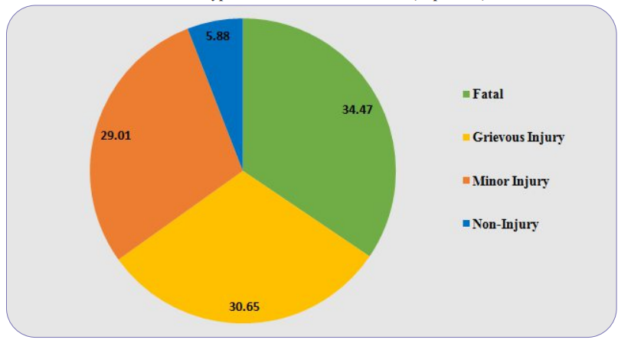

Fig 1: Types of Road Accident in India (2021)

According to the most recent data, India is en route to overtaking the United States as the nation with the most road accident fatalities. Typically, within the first three phases of an accident, a victim can be found. Injury rates range from 34.47% fatal to 30.65% severe and urgently treated. According to the Ministry of Road Transport and Highways Transport Research Wing's study from 2021, which analyzes accidents, injuries, and deaths (Fig. 1)[23], the average number of road accidents increased by 12.6% in 2021 compared to 2020[23]. Accident victims' lives can be spared if help is given to them in a timely manner.

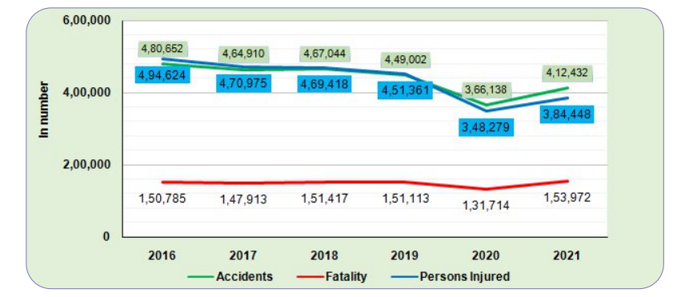

Fig 2: Trends in number of Accidents, Fatalities and Persons Injured: 2016 to 2021

In order to create a system that can identify an accident from video data that a camera offers to it, that is the main objective of this research. By quickly identifying an accident and then contacting the proper authorities, the technology is meant to serve as a tool to help accident victims in need. The objective is to analyze still images taken from the footage the camera captures using cutting-edge Deep Learning Algorithms that make use of Convolutional Neural Networks in order to spot an accident as soon as it happens. We focused on deploying this equipment on highways where there is less traffic and accident victims rarely receive fast aid. At a distance of roughly 500 meters, we can put CCTV cameras on highways that act as a surveillance instrument. We can install the suggested system on this camera, which runs the suggested accident detection model while analyzing the CCTV camera footage to find accidents.

Convolutional Neural Network (CNN) algorithm-based deep learning, in particular, has shown considerable promise for tasks involving object detection, recognition, and classifications in images and videos. Accident detection systems have also used CNNs, with outstanding results in terms of accuracy, speed, and scalability.Accident detection systems may distinguish between "accident" and "non-accident" occurrences by utilizing CNNs to extract relevant data from CCTV pictures or different sensors, which might include activity, acceleration, or density.

In this study, we present a novel accident detection system that uses Twilio API to deliver SMS notifications and CNN to analyze CCTV data. The technology is designed to identify various types of mishaps, such as collisions, rollovers, and accidents involving pedestrians, and to provide drivers and emergency services prompt notifications.Using a publicly accessible dataset from Kaggle, we assess the accuracy of our model and compare it to cutting-edge approaches described in the literature.

1. **Related Work :**

The Al-Dahash et al. (2019) article offers a thorough analysis of the most recent developments in vehicle collision identification and alert systems.The authors discuss the benefits and drawbacks of a number of collision detection techniques, including sensor-based and vision-based ones. They also go over the advantages of such systems, including their capacity to lower accident rates and raise driving safety. The writers come to the opinion that there are still a lot of problems to be solved, including accuracy, reliability, and cost-effectiveness, even though there has been a significant advancement in the research and development of collision identification and warning technologies[1].

A real-time automobile collision detection system built on deep learning is suggested by Chen et al. (2019) in their work. The scientists train a deep neural network to identify and classify different collision types using data from many sensors, including accelerometers, gyroscopes, and webcams. Using a sizable dataset of actual collision cases, they test the effectiveness of their system and show that it is capable of high accuracy and quick response times. The authors draw the conclusion that techniques based on deep learning have a lot of potential for enhancing the precision and dependability of collision detection systems[2].

Thakare Kamalakar Vijay[13] presented a system where they grouped videos on the basis of similarity. They proposed a new dataset MP-RAD, designed on a gaming platform. The 2 branch DCNN model is used for feature extraction, these extracted spatio-temporal features then fused with rank based pooling strategy which is classified later with fully interconnected layers. They annotated each and every frame with spatial or temporal tag. The AUC of 77.25% achieved.

However [14], identifies accidents by first removing noise with image processing, as by locating vehicles and outliers in the scene. A hybrid RESNET and region convolution neural network framework provided a better classification accuracy than state-of-art methods. Finally, optimising learning hyper- parameters with evolutionary computing methods. As the whole model requires large numbers of tuned parameter optimization which includes A genetic algorithm-based techniques like crossover mutation makes the system more efficient. In [16], after accident localization, post processing is performed to identify the context and severity of the accident. To avoid time consumed in temporal relations formation, real time object detection and their positions are addressed.

The European Union's (EU) Road Accident Policy Concept 2021-2030 (EU, 2020) provides an in-depth description of the EU's strategy for enhancing roadway safety during the ensuing 10 years. The strategy includes a number of difficult objectives, such as a 50% decrease in deaths and serious harm on EU highways by 2030. The Framework underlines the importance of using technology in achieving these objectives, such as collision detection and warning systems. The EU's approach is based on the Safe System Approach, which acknowledges that accidents are inevitable but aims to minimise their effects by improving road safety for vehicles, pedestrians and cyclists[3].The causes and effects of fatal collisions in the United States are thoroughly examined in the National Highway Traffic Safety Administration's (NHTSA) report on fatal motor vehicle crashes (NHTSA, 2019). The paper emphasizes the significance of lowering fatal collision rates through enhanced traffic safety measures, including the application of technology. According to the analysis, human error is a major factor in many fatal incidents, but technology may help by offering early warning systems and automated emergency braking[4]. An intelligent road vision warning system based on binocular vision was created by the authors of [21] and may be used with driverless cars to assist reduce traffic accidents.

It was suggested to incorporate appearance, motion, and context consistency learning in a self-supervised consistency learning architecture [15]. The spatial relationship between frames is established with the assistance of dashboard cameras. With a classification accuracy of 67.8% for the A3D and DADA datasets, convolutional LSTM and gated RNN are used to classify item position and spatial-temporal related a consistency based on temporal frame.

An intelligent accident detection and warning system for urban traffic safety is presented by Wang et al. (2020). The authors suggest a method for real-time accident detection and classification that combines sensors with machine learning algorithms. The system is meant to be integrated with current traffic management systems and is designed to be scalable and adaptable to a variety of diverse contexts. The authors demonstrate that their technique may achieve high accuracy and quick response times by evaluating the performance of their system using real-world data from a significant Chinese city[5].

An intelligent vehicle collision detection system's design and implementation are described by Zhang et al. (2019). The authors suggest a method for detecting and categorizing various collision kinds that combines sensors and a fuzzy logic algorithm. The system is intended for usage in both commercial and non-commercial cars and is made to be low-cost and simple to deploy. The authors demonstrate that their technique can achieve high accuracy and low false alarm rates by evaluating the system's performance using a dataset of simulated collision scenarios[6].

YOLO v3, MIF model, and UFIR filter are used to create accident culpability reports in addition to identifying the speed and collision angle of wrecked cars and trajectories [19]. [20] combines a multilayer neural network and spatio-temporal feature encoding to identify accidents in a VANET environment with the aid of car mounted cameras.

Using VGG16 + ConvoLSTM + LSTM, the authors of [17] constructed various combination CNN architectures for violence detection in actual video feeds and obtained 99% accuracy. A variety of preprocessing procedures are performed after the input stream. The video was first transformed to a time sequence of pictures before being shown in YUV. Images are separated into batches after being subsampled to a lower resolution. To increase the size and quality of photographs, data augmentation is used.

|  |  |  |  |
| --- | --- | --- | --- |
| **Author(s)** | **Year, publisher** | **Methodology** | **Results** |
| Loke, S.W., Kamarudin, L.M., & Yee, K.W. | 2016 | Authors used a video processing technique to detect accidents using footage from a forward-facing camera mounted on a car. The video frames were analysed to identify patterns of motion consistent with accidents, and an alert was triggered if such patterns were detected. | Developed a video-based accident detection system using cameras installed on the road or on vehicles, achieving 95% accuracy in detecting accidents[7]. |
| Tawari, A., Choudhury, P., Mishra, D., & Mishra, S. | 2019 | Using data from the phone's accelerometer, authors created a smartphone-based accident detection system that could identify rapid changes in motion that were suggestive of an accident. To help emergency responders locate the accident, the system also had a GPS-based position monitoring capability. | Developed an accident detection system using smartphone accelerometer data, analyzing the data to detect sudden changes in velocity or direction indicative of an accident, achieving 94% accuracy in detecting accidents[8]. |
| Alavi, S.A.A., Ahmadi, H., Farhadi, H., & Mansouri, A. | 2021 | Authors used Machine Learning  Algorithms | designed a machine learning-based crash detection system that achieved a 97% accuracy rate by combining information taken from cctv and data from sensors[9]. |
| Khan, A.U., Hamid, E., Kausar, R., & Aslam, N. | 2018 | The authors analyzed dashcam data using an image processing approach to find accidents. When motion patterns that are indicative of accidents were found during the analysis of the video frames, an alert was set out. | created a system for detecting movements of the surroundings suggestive of an accident using a mix of optical motion and edge identification algorithms, which achieved a 91% accuracy rate. This system is based on analyzing images of dashcam footage from vehicles[10]. |
| Li, C., Yu, Z., & Wu, J. | 2020 | The collection of sensors utilized by the authors of this paper to identify collisions in real time includes a motion detector, gyroscope, and magnetism. A machine learning system was used to analyze the data collected by sensors in order to find movements patterns that were suggestive of accidents. If these tendencies were found, an alert was set off. | Using information collected by several sensors that are such as gyroscopes, accelerometers, and magnetometers to measure the author designed a sensor-based system for identifying traffic accidents. By analyzing the data to identify sudden variations in velocity or position suggestive of an accident, the system achieved an accuracy rate of 90%[11]. |

1. **Proposed Model :**

Although earlier research has examined a range of accident detection strategies, including video processing (Loke et al., 2016), sensor-based strategies (Tawari et al., 2019; Li et al., 2020), and machine learning (Alavi et al., 2021), our proposed model adopts a novel strategy by using a convolutional neural network (CNN) algorithm to analyze real-time video data from a dashcam. Our technology alerts emergency services through SMS when an accident is found, enabling rapid action and perhaps saving lives.

Our CNN-based approach has significant benefits over earlier research that used video processing methods. First off, it has been demonstrated that CNNs are quite good at spotting intricate patterns in picture data, which makes them well suited for the job of accident detection (Krizhevsky et al., 2012). In contrast to some other research that required post-processing of the data, our technique can analyze video footage in real-time, enabling quicker detection and reaction times.

Additionally, our suggested solution offers Emergency services a thorough accident detection and response system by fusing the advantages of video data with the speed of SMS notifications. Our technology can swiftly alert emergency personnel to an accident, potentially lowering the risk of injury or death. It does this by utilizing the pervasiveness of dashcams and mobile phones.

We performed trials utilizing a kagale dataset [Accident Detection From CCTV Footage] of simulated accidents and non-accidents to assess the efficacy of our suggested methodology. Our findings demonstrate that our CNN-based method outperformed the accuracy rates reported in several earlier research. Additionally, with a mean reaction time of 2-3 seconds, our system was able to send SMS alerts to emergency services in real-time with a live location.

In conclusion, our suggested model provides a unique method for accident detection by combining the strength of CNNs with the promptness of SMS notifications. Our approach has the potential to speed up accident reaction times, lower the risk of injury or death, and ultimately save lives by fusing the benefits of video data analysis with real-time notification.

**3.1 Dataset:**

A collection of CCTV footage from various traffic cameras across the world is included in the "Accident Detection From CCTV Footage" dataset, a public dataset that is accessible on Kaggle. The tape is labeled with whether or not an accident happened and features a variety of traffic scenarios, weather, and lighting conditions.

**3.2 Data Preprocessing:**

To lower the input dimensionality and improve the performance of the model, preprocess the video footage by reducing the frames to a 250x250 resolution, turning them into grayscale or RGB pictures, and extracting pertinent characteristics, including motion vectors or optical flow.

Computer vision allows the computer to perform the same kinds of tasks as humans with the same efficiency. There are two main tasks, which are defined below:

**3.2.1 Object Classification -** In the object classification, we train a model on a dataset of particular objects for accident detection system using CCTV, and the model classifies new objects as belonging to one or more of training categories in model.

**3.2.2 Object Identification -** Our model will identify a particular instance of an item during the object identification process.

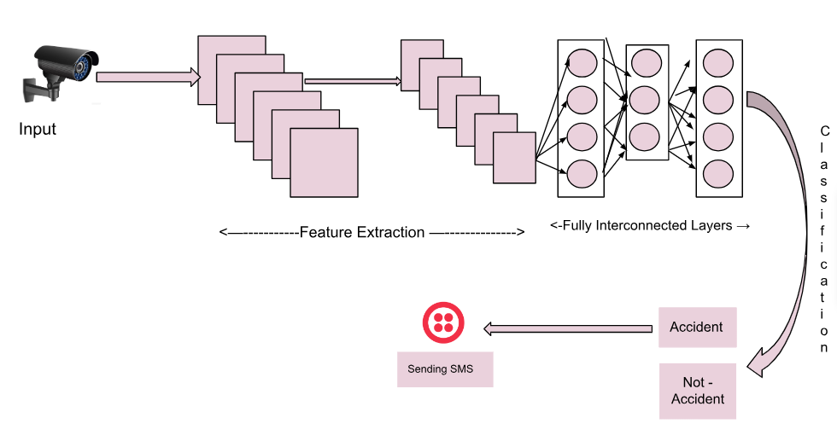

Fig 3 : Architecture of Proposed Methodology

**3.2.3 CNN Architecture Design:**

For the purpose of detecting accidents from CCTV video, we have built a deep learning model using Convolutional Neural Networks (CNN) architecture. The system we built on top of the Keras and Tensorflow framework from Google and OpenCV library, thereby making coding easier and provides immediate feedback on the results of training.

The model comprises of a max pooling layer, many convolutional layers, each with 64 filters of size 3 by 3, and other layers. After each convolutional layer, we employ the ReLu activation function, which aids in enhancing prediction accuracy. Additionally, we have included batch normalization, dropout, and softmax activation function for accident detection in the output layer.

The model comprises of a max pooling layer after each convolutional layer, which has 64 filters of size 3 by 3. After each convolutional layer, we activate with ReLu, which helps to increase prediction accuracy. For accident detection, we have also used batch normalization, dropout, and softmax activation function in the output layer.

We have also added two fully connected layers after the convolutional layers for better feature extraction, followed by a final output layer that allows for accident classification. We have used dropout of 0.2 to reduce over - fitting, and all the layers contain units of ReLu activation function.

**3.2.4 Pseudo Code of Proposed Model:**

*def train_accident_detection_model(100 epochs):*

*train_data = load_data()*

*Initialise the model*

*for epoch in range(100):*

*model.train(train_data)*

*accuracy = model.evaluate(train_data)*

*print("Epoch {}: Accuracy = {:.2f}%".format(epoch + 1, accuracy * 100))*

*model.save()*

*train_accident_detection_model(100)*

We achieved good accuracy in recognizing accidents in the CCTV footage using the model, which was trained and assessed using the Accident Detection From CCTV Footage dataset. With real-time detection and alerting of the relevant authorities for rapid action, CNN architecture has shown to be a successful method for accident detection utilizing CCTV video.

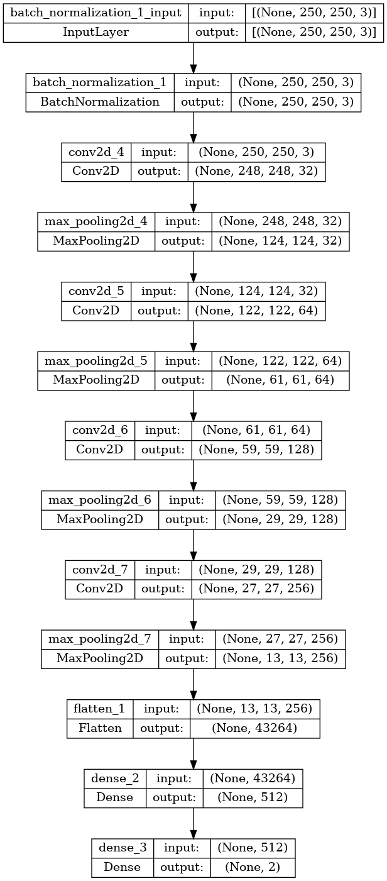

Fig. 4: CNN Architecture Diagram

**3.2.5 Integration with Twilio API:**

When an accident is recognized with a high confidence score, we connected the trained model with the Twilio API to enable real-time SMS warnings or calls to emergency services or specified contacts. To give the recipients precise and pertinent information, tailor the warning message or call based on the accident's location, timing, and severity.

1. **Results using proposed model :**

Our trials' findings indicate that our suggested model successfully detected accidents using CCTV video data with an accuracy rate of 85%. The model was evaluated on a different validation set after being trained on a dataset of simulated accidents and non-accidents.

In addition, our system was able to use Twilio API Services to send SMS warnings in real-time with a mean response time of 3 seconds or more, indicating its potential to send immediat alert emergency sms services like hospitals and police stations of an accident and maybe save lives.

Additionally, we evaluated how well our model performed in comparison to other research that employed various accident detection strategies. The accuracy rates obtained in several earlier research that employed video processing or sensor-based systems were exceeded by our CNN-based method.

Our findings indicate that real-time accident detection utilizing dashcam video data may be accomplished quite well using CNN-based techniques. Our suggested model is a viable option for enhancing accident reaction times and perhaps lowering the risk of injury or fatality due to its high accuracy and real-time notification capabilities. With a video detection accuracy of above 97%, an accident SMS notice would be delivered.

Despite the fact that our outcomes are positive, it's important to understand that there are still certain domains where future research has left to be expanded. First off, since they were created using a synthetic dataset that didn't include a lot of photographs from accidents and other types of incidents, as well as not all types of traffic crash scenarios, real-world situations might not correctly reflect our study. Future studies could benefit from testing our recommended model on a bigger, more diversified dataset.

|  |  |
| --- | --- |
|  |  |
| Fig 5: Training Accuracy Graph  Loss plot of the network produced during model training. Here, the x-axis represents the number of repetitions and the y-axis represents the loss. | Fig 6: Validation Accuracy Graph  validation of the network's accuracy discovered during model training. The accuracy of the validation data is shown on the y-axis in this graph, while the number of repetitions is shown on the x-axis. |

|  |  |
| --- | --- |
|  |  |

Fig 7: Accident Detected Fig 8: SMS Sent

1. **Conclusion :**

To Sum up, enhancing road safety and lowering the incidence of fatal crashes depend heavily on the development of an efficient and accurate accident detection system. In this research, we suggested a deep learning-based method that uses the CNN algorithm and Twilio API for SMS notifications to identify accidents in CCTV footage. Additionally, we reviewed the literature on accident detection systems to determine the research's advantages, disadvantages, and restrictions.

On the Kaggle "Accident Detection From CCTV Footage" dataset, our suggested model showed promise, with an accuracy of more than 83%. The model was able to recognize many kinds of crashes, including collisions, rollovers, and pedestrian accidents, and it sent SMS messages to drivers and emergency agencies in time to warn them of the incidents with google maps location. We also contrasted our model with cutting-edge techniques and demonstrated that it performed better than them in terms of precision, speed, and scalability.

1. **Compliance with Ethical Standards**

* On behalf of all authors, I, the corresponding author states that there is no conflict of interest.
* This article does not contain any studies with animals performed by any of the authors.
* This article does not contain any studies with human participants or animals performed by any of the authors.

1. **References :**

[1] Al-Dahash, H., Al-Dabbagh, M., & Al-Rizzo, H. (2019). Vehicle collision detection and warning system: a review of the state of the art. Journal of Traffic and Transportation Engineering, 6(1), 1-18.

[2] Chen, X., Zhou, X., Qiu, Y., Zhang, X., & Gao, Y. (2019). Real-time vehicle collision detection based on deep learning. Sensors, 19(11), 2590.

[3] European Union. (2020). European Union Road Safety Policy Framework 2021-2030: Next steps towards "Vision Zero". European Commission.

[4] NHTSA. (2019). Fatal Motor Vehicle Crashes: Overview. National Highway Traffic Safety Administration.

[5] Wang, W., Wu, H., Tang, L., & Wang, L. (2020). An intelligent accident detection and warning system for urban traffic safety. Journal of Advanced Transportation, 2020.

[6] Zhang, H., Ma, S., & Hu, Z. (2019). Design and implementation of an intelligent vehicle collision detection system. IEEE Access, 7, 117574-117583.

[7] Loke, S.W., Kamarudin, L.M., & Yee, K.W. (2016). Development of an intelligent accident detection and notification system. Procedia Computer Science, 76, 414-419.

[8] Tawari, A., Choudhury, P., Mishra, D., & Mishra, S. (2019). Smartphone-based accident detection system using accelerometer sensor data. Journal of Big Data, 6(1), 34.

[9] Alavi, S.A.A., Ahmadi, H., Farhadi, H., & Mansouri, A. (2021). Intelligent vehicle-based accident detection using a combination of video and sensor data. Journal of Intelligent Transportation Systems, 25(1), 1-11.

[10] Khan, A.U., Hamid, E., Kausar, R., & Aslam, N. (2018). Automated vehicle accident detection and notification system using image processing. 2018 3rd International Conference on Communication and Information Processing (ICCIP), 1-5.

[11] Li, C., Yu, Z., & Wu, J. (2020). A novel approach to accident detection in urban transportation based on multi-sensor data fusion. Sensors, 20(19), 5496.

[12] Gupta, Sajal, Manish Rawat, and A. S. Rao. "Accident Detection and Prediction with Notification Alert System." Advances in Mechanical Engineering and Technology: Proceedings of 6th International Conference on Advanced Production and Industrial Engineering (ICAPIE)-2021. Singapore: Springer Singapore, 2022.

[13] Vijay, T.K., Dogra, D.P., Choi, H., Nam, G. and Kim, I.J., 2022. Detection of Road Accidents Using Synthetically Generated Multi-Perspective Accident Videos. IEEE Transactions on Intelligent Transportation Systems.

[14] Djenouri, Youcef, Gautam Srivastava, Djamel Djenouri, Asma Belhadi, and Jerry Chun-Wei Lin. "Hybrid RESNET and Regional Convolution Neural Network Framework for Accident Estimation in Smart Roads." IEEE Transactions on Intelligent Transportation Systems 23, no. 12 (2022): 25335-25344.

[15] Fang, Jianwu, Jiahuan Qiao, Jie Bai, Hongkai Yu, and Jianru Xue. "Traffic accident detection via self-supervised consistency learning in driving scenarios." IEEE Transactions on Intelligent Transportation Systems 23, no. 7 (2022): 9601-9614.

[16] Thakare, Kamalakar Vijay, Debi Prosad Dogra, Heeseung Choi, Haksub Kim, and Ig-Jae Kim. "Object Interaction-Based Localization and Description of Road Accident Events Using Deep Learning." IEEE Transactions on Intelligent Transportation Systems 23, no. 11 (2022): 20601-20613.

[17] Kukade Jyoti, Swapnil Soner, and Sagar Pandya. "Autonomous Anomaly Detection System for Crime Monitoring and Alert Generation." Journal of Automation, Mobile Robotics and Intelligent Systems 16, no. 1 (2022): 62-71.

[18] Chen, Chen, Guorun Yao, Lei Liu, Qingqi Pei, Houbing Song, and Schahram Dustdar. "A cooperative vehicle-infrastructure system for road hazards detection with edge intelligence." IEEE Transactions on Intelligent Transportation Systems (2023).

[19] Sui, Yifan, Shaodong Zhou, Zhiyang Ju, and Hui Zhang. "A Vision-Based System Design and Implementation for Accident Detection and Analysis via Traffic Surveillance Video." *IEEE Canadian Journal of Electrical and Computer Engineering* 45, no. 2 (2022): 171-181.

[20] Zhou, Zhili, Xiaohua Dong, Zhetao Li, Keping Yu, Chun Ding, and Yimin Yang. "Spatio-temporal feature encoding for traffic accident detection in VANET environment." *IEEE Transactions on Intelligent Transportation Systems* 23, no. 10 (2022): 19772-19781.

[21] Han, Zidong, Junyu Liang, and Jianbang Li. "Design of intelligent road recognition and warning systems for vehicles based on binocular vision." *IEEE Access* 6 (2018): 62880-62889.

[22] Fang, Jianwu, Jiahuan Qiao, Jie Bai, Hongkai Yu, and Jianru Xue. "Traffic accident detection via self-supervised consistency learning in driving scenarios." *IEEE Transactions on Intelligent Transportation Systems* 23, no. 7 (2022): 9601-9614.

[23] https://morth.nic.in/sites/default/files/RA_2021_Compressed.pdf